Mon. Feb. 9, 2026 ATMS 502, CSE 566 Jewett
Homework #1 – due Mon., Feb. 16, 2026

- You are encouraged to work with others on this assignment,
... but what you hand in must be your own work. No copying allowed!
- Also: • solutions must be handwritten; no typing!
- Provide your answers on separate sheets of paper - not this one.
- Consider this equation: $\frac{∂^{2}u}{∂x^{2}}+xyu\frac{∂^{2}u}{∂x∂y}-7x^{4}\frac{∂^{2}u}{∂y^{2}}=0$
- Is this partial differential equation linear? Why or why not?
- What is the order of this differential equation?
- Regarding the Lotka-Volterra solutions we looked in class:
- Give a brief description of the kinds of errors that were apparent.
- Based on the plots that were shown in class, under what circumstances would the method we used converge to the correct solution?
- Consider the 2-D staggered (Arakawa C) grid, with scalar variables at each grid box center. The C-grid velocity variables (u, v) are located at
(choose one):
  - same location as scalar (e.g. pressure, temperature) variables
  - parallel-flow sides of the grid box: y-velocity v is staggered $±\frac{∆x}{2}$
  - normal-flow sides of the grid box: x-velocity u is staggered $±\frac{∆x}{2}$
- To the question:
“how do wavenumber-dependent phase errors distort the solution?”
I require a two part answer.
  - We first suppose that any solution can be represented as
an infinite series of … (finish this sentence)
  - We then say that, if individual wavenumber components travel at different phase speeds, then … (finish this sentence)
continued on next page.
- Consider this numerical scheme: $\frac{\left(q_{j}^{n+1}-q_{j}^{n}\right)}{∆t}+c\frac{\left(q_{j+1}^{n}-q_{j-1}^{n}\right)}{2∆x}=0$
… as a (poor!) approximation to the 1-way wave equation.
- Derive truncation error (T.E.) and express the resulting equation with PDE terms on the left side of the equals sign, and T.E. on the right.
- State the order of accuracy – i.e. order {(∆x)^{m}, (∆t)^{n}}: what are m, n?
- Is it consistent with the PDE, $\frac{∂q}{∂t}+c\frac{∂q}{∂x}=0$? How do you know?
- Use von Neumann’s method to show this is absolutely unstable
(• assume Courant number and the nondimensional wavenumber are nonzero)
- Which computational molecule (a, b, or c) represents this method?

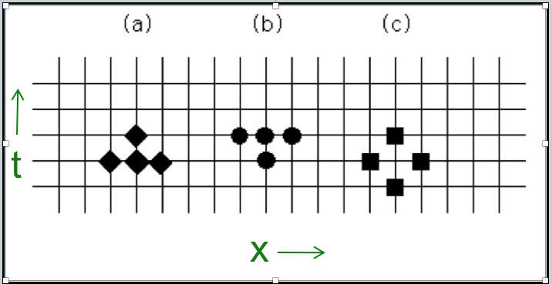
- Study the following polar plots carefully. Amplification factor $\left|G\right|$is on the left side, and relative phase error is on the right. For Courant number $ν=0.75$, estimate (by eyesight, no ruler required):
  - the approximate amplification factor $\left|G\right|$for $2∆x$ and $4∆x$ waves.
  - the approximate phase error (ratio, $\frac{ϕ}{ϕ_{e}}$) for $2∆x$ and $4∆x$ waves.
